New Patient Report – Page 1
05/15/2024

The current Patient Report, found on the menu items as shown here:
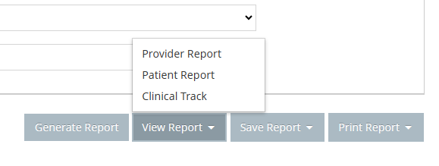

A sample of which is shown here:

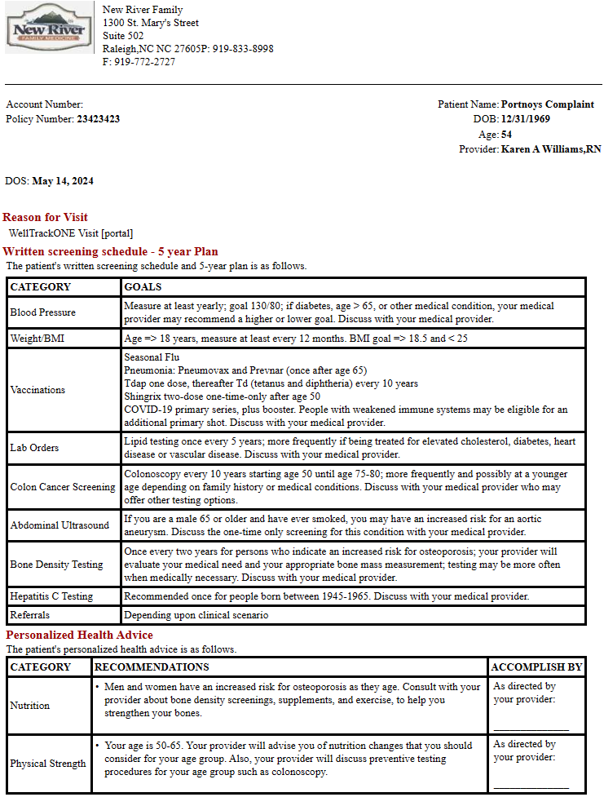

Needs to be replaced with a more modern, updated Patient Report that more closely mimics the Patient Report that used to be generated by the iOS THEO I product, a version of which is shown here:

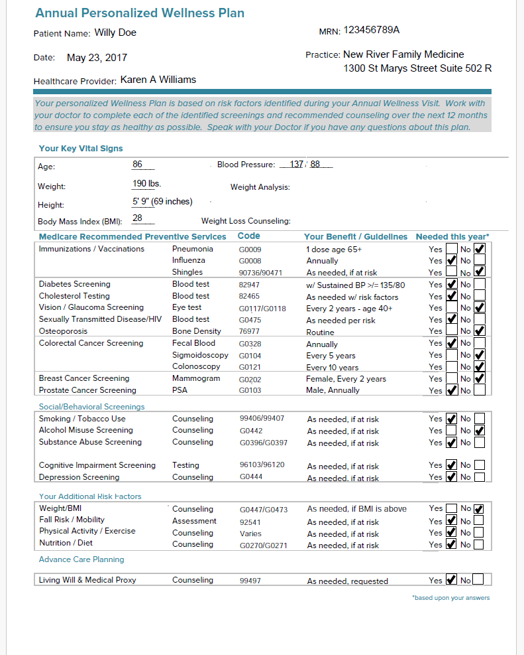

This patient report needs to be available from /tablet (PreventONE), /theo (THEO II) and /portal (ConnectONE) – ALL THREE PLATFORMS!

Entry variables

You will need the following variables from the calling program in order to run the queries required to generate this data:

- Patient_ID (For Wellness_eCastEMR_Data.dbo.PatientProfile)
- Encounter_ID (For Wellness_eCastEMR_Data.dbo.EncounterHistory)

You will also need the following variables to fetch other data needed for the report:

- Org_ID (For Wellness_eCastEMR_Data.dbo.OrgProfile)
- Provider_ID (For Wellness_eCastEMR_Data.dbo.ProviderProfile)

The SQL query that generates the data you need for the report will be shown in
Attachment “A” – Patient Wellness SQL Query. The two variables above must be initialized inside the query as @Patient_ID and @Encounter_ID prior to running the query.

They must also be initialized in the query that runs the report to give you the final data.

The programmer will need to get the header for the report as shown:

For Patient Name:
- SELECT FirstName, LastName, MedicalRecordNumber FROM Wellness_eCastEMR_Data.dbo.PatientProfile where Patient_ID = @Patient_ID

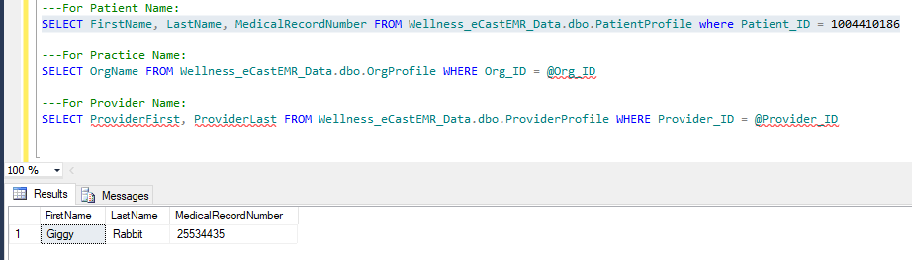

For Practice Name:
- SELECT OrgName FROM Wellness_eCastEMR_Data.dbo.OrgProfile WHERE Org_ID = @Org_ID

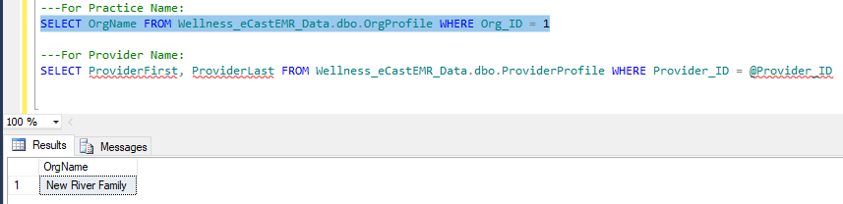

For Provider Name:
- SELECT ProviderFirstName, ProviderLastName FROM Wellness_eCastEMR_Data.dbo.ProviderProfile WHERE Provider_ID = @Provider_ID

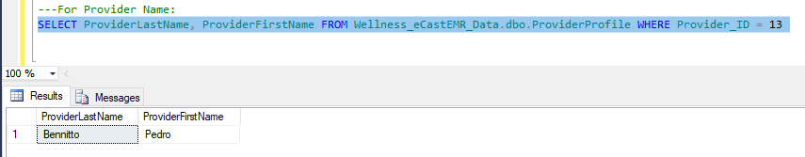

For BMI:

- The BMI formula in English units is BMI = mass (lb) * 703 (height (in))2¹²³⁴. In this formula, lb stands for pound and in stands for inch¹. When using English measurements, ounces (oz) and fractions must be changed to decimal values². The formula can also be written as BMI = (Weight in Pounds / (Height in inches x Height in inches)) x 703³. The formula is used to calculate BMI by dividing weight in pounds (lb) by height in inches (in) squared and multiplying by a conversion factor of 703⁴.

Formatting:

For your report output, copy the formatting, font, color, font size exactly as you see it in the report.

Check boxes require a “check” image inside the box which must be replicated exactly as shown above.

Data for Report:

To make it extremely easy for the programmer to access the data, we have provided a table called “Wellness_eCast_DataArchive.dbo.PWHistory” and “Wellness_eCast_DataArchive.dbo.PWMaster” that will render the exact set of data that you need, in the order of presentation on the report (following “SortOrder”).

Here is a sample output of the query that outputs what you need to get the data for this report:

SELECT PWM.PWMaster_ID,PWM.Category,PWM.Service,PWM.Code,PWM.Benefit,PWH.PWValue,PWH.PWNeeded,PWM.SortOrder
FROM Wellness_DataArchive.dbo.PWHistory PWH
JOIN Wellness_DataArchive.dbo.PWMaster PWM
ON PWH.PWMaster_ID = PWM.PWMaster_ID
WHERE Patient_ID = 1004373998 AND Encounter_ID = 656443 AND
(PWH.Hidden IS NULL or PWH.Hidden = 0)
ORDER BY PWH.SortOrder

Note that this query has the Patient_ID and Encounter_ID hard coded for illustration purposes. Your program will need to substitute those hard coded values with the variables from within your code.

The Query in Attachment “A” will be part of your code that generates this new Patient Wellness report. It does not depend upon the “Generate Report” button because it reads the stored template data directly.

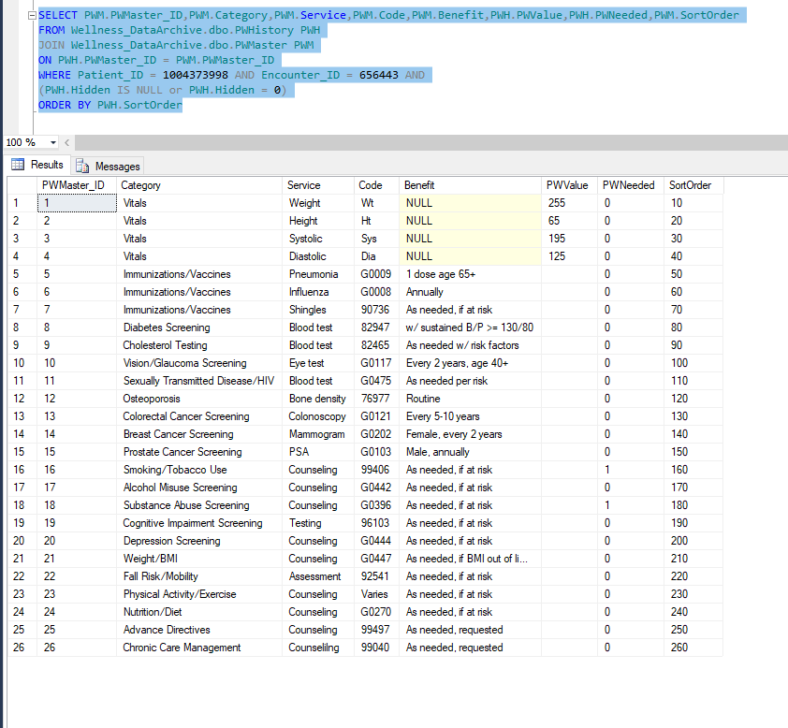

If you look carefully at the output of this query, and compare it to the “new” patient report, you will see that the items on the report line up perfectly with the output of this query. That is BY DESIGN.

The first four rows are the vitals for weight (lbs), height (inches), systolic (inches Hg) and diastolic (inches Hg).

The remaining rows correspond to the lines on the report.

The column “PWNeeded” is 1 if “yes” and 0 if “no”. This tells you where to put the check marks in the box on the report.

Attachment “A” – Query for Patient Wellness

/* Patient Wellness Generator
Code to find Patient Wellness Inclusion Data
UPDATE: 05/12/2024 PAB New

*/
--- For Repetitious Testing Only
---DELETE FROM Wellness_DataArchive.dbo.PWHistory

---SELECT * FROM Wellness_DataArchive.dbo.PWMaster
---SELECT * FROM Wellness_DataArchive.dbo.PWMasterTBots

PRINT 'Setting up temp tables...'
USE Wellness_eCastEMR_Data
GO
DROP Table Wellness_eCastEMR_Data.dbo.tempPWTBots
GO
SET ANSI_NULLS ON
GO
SET QUOTED_IDENTIFIER ON
GO
SET ANSI_PADDING ON
GO
CREATE TABLE Wellness_eCastEMR_Data.[dbo].[tempPWTBots](
[tempPWTBots_ID] [int] IDENTITY(1,1) NOT NULL,
[TBot] varchar(10) )
GO
CREATE INDEX tempPWTBots_idx
ON Wellness_eCastEMR_Data.dbo.tempPWTBots(TBot)
GO

PRINT 'Got the Encounter_ID and now filling up temp table...'
SET ANSI_PADDING OFF

DECLARE @Patient_ID INT, @Encounter_ID INT, @n INT, @max INT,
@PWCategory Varchar(50), @PWService Varchar(50), @PWCode Varchar(10),
@PWBenefit Varchar(50),@PWNeeded SmallInt, @PWMaster_ID INT, @TDate DATE, @PWSortOrder SMALLINT

/* Calling code needs to run these two lines before calling this SQL Code
Your code needs to populate these variables with the actual patient values */
SELECT @Encounter_ID = 656443
SELECT @Patient_ID = 1004373998

--- For LIVE Production…
PRINT 'Setting PWHistory flags...'
UPDATE Wellness_DataArchive.dbo.PWHistory
SET Hidden = 1 WHERE
Patient_ID = @Patient_ID AND
Encounter_ID = @Encounter_ID

/* End of code needed by calling code */

/* This is a required value for PWHistory */
SELECT @TDate = GetDate()

/* This block will fetch the vitals and INSERT them into PWHistory*/
PRINT 'Inserting first 4 rows of PWHistory...'

INSERT INTO Wellness_DataArchive.dbo.PWHistory
(PWMaster_ID, Patient_ID, Encounter_ID, PWDate, PWNeeded, PWValue, SortOrder, Hidden)
VALUES
(1,@Patient_ID,@Encounter_ID,@TDate,0,'Weight: ',10,0),
(2,@Patient_ID,@Encounter_ID,@TDate,0,'Height: ',20,0),
(3,@Patient_ID,@Encounter_ID,@TDate,0,'Systolic: ',30,0),
(4,@Patient_ID,@Encounter_ID,@TDate,0,'Diastolic: ',40,0)

PRINT 'Now updating first 4 rows of PWHistory with correct vitals values...'

--- Weight
UPDATE PWH
SET PWH.PWValue = E3I.ETL3Input
FROM Wellness_DataArchive.dbo.PWHistory PWH
INNER JOIN Wellness_eCastEMR_Data.dbo.ETL3Input E3I ON PWH.Encounter_ID = E3I.Encounter_ID
INNER JOIN Wellness_eCastEMR_Template.dbo.TML3 T3 ON E3I.TML3_ID = T3.TML3_ID
INNER JOIN Wellness_eCastEMR_Template.dbo.TML2 T2 ON T3.TML2_ID = T2.TML2_ID
INNER JOIN Wellness_eCastEMR_Data.dbo.ETL1 E1 ON T2.TML1_ID = E1.TML1_ID
WHERE PWH.PWMaster_ID = 1
AND E1.Encounter_ID = @Encounter_ID
AND T2.TML2_HeaderMaster_ID = 33
AND T3.TML3_TBotMaster_ID = 424;

--- Height
UPDATE PWH
SET PWH.PWValue = E3I.ETL3Input
FROM Wellness_DataArchive.dbo.PWHistory PWH
INNER JOIN Wellness_eCastEMR_Data.dbo.ETL3Input E3I ON PWH.Encounter_ID = E3I.Encounter_ID
INNER JOIN Wellness_eCastEMR_Template.dbo.TML3 T3 ON E3I.TML3_ID = T3.TML3_ID
INNER JOIN Wellness_eCastEMR_Template.dbo.TML2 T2 ON T3.TML2_ID = T2.TML2_ID
INNER JOIN Wellness_eCastEMR_Data.dbo.ETL1 E1 ON T2.TML1_ID = E1.TML1_ID
WHERE PWH.PWMaster_ID = 2
AND E1.Encounter_ID = @Encounter_ID
AND T2.TML2_HeaderMaster_ID = 33
AND T3.TML3_TBotMaster_ID = 423;

--- Systolic
UPDATE PWH
SET PWH.PWValue = E3I.ETL3Input
FROM Wellness_DataArchive.dbo.PWHistory PWH
INNER JOIN Wellness_eCastEMR_Data.dbo.ETL3Input E3I ON PWH.Encounter_ID = E3I.Encounter_ID
INNER JOIN Wellness_eCastEMR_Template.dbo.TML3 T3 ON E3I.TML3_ID = T3.TML3_ID
INNER JOIN Wellness_eCastEMR_Template.dbo.TML2 T2 ON T3.TML2_ID = T2.TML2_ID
INNER JOIN Wellness_eCastEMR_Data.dbo.ETL1 E1 ON T2.TML1_ID = E1.TML1_ID
WHERE PWH.PWMaster_ID = 3
AND E1.Encounter_ID = @Encounter_ID
AND T2.TML2_HeaderMaster_ID = 33
AND T3.TML3_TBotMaster_ID = 425;

--- Diastolic
UPDATE PWH
SET PWH.PWValue = E3I.ETL3Input
FROM Wellness_DataArchive.dbo.PWHistory PWH
INNER JOIN Wellness_eCastEMR_Data.dbo.ETL3Input E3I ON PWH.Encounter_ID = E3I.Encounter_ID
INNER JOIN Wellness_eCastEMR_Template.dbo.TML3 T3 ON E3I.TML3_ID = T3.TML3_ID
INNER JOIN Wellness_eCastEMR_Template.dbo.TML2 T2 ON T3.TML2_ID = T2.TML2_ID
INNER JOIN Wellness_eCastEMR_Data.dbo.ETL1 E1 ON T2.TML1_ID = E1.TML1_ID
WHERE PWH.PWMaster_ID = 4
AND E1.Encounter_ID = @Encounter_ID
AND T2.TML2_HeaderMaster_ID = 33
AND T3.TML3_TBotMaster_ID = 426;

/* Mow insert rows into tempPWTBots */
PRINT 'Setting all other report values in tempPWTBots...'
INSERT INTO Wellness_eCastEMR_Data.[dbo].[tempPWTBots]
SELECT CONCAT(TM.TML3_TBotMaster_ID,'-',TM.TML3_TBotData) FROM Wellness_eCastEMR_Data.dbo.ETL3 ET
JOIN Wellness_eCastEMR_Template.dbo.TML3 TM ON ET.TML3_ID = TM.TML3_ID
JOIN eCastMaster.dbo.TBotMaster TB ON TM.TML3_TBotMaster_ID = TB.TBotMaster_ID
WHERE ET.Encounter_ID = @Encounter_ID

PRINT 'Starting the loop through PWMaster...'
SELECT @n = 5 --- Skip first 4 rows which are Vitals
SELECT @max = COUNT(*) FROM Wellness_DataArchive.dbo.PWMaster
WHILE @n <= @max
BEGIN
PRINT 'Looping through PWMaster...'
--- Load up your variables for the INSERT into PWHistory
SELECT
@PWMaster_ID = PWMaster_ID,
@PWCategory = Category,
@PWService = Service,
@PWCode = Code,
@PWBenefit = Benefit,
@PWNeeded = 0,
@PWSortOrder = SortOrder
FROM Wellness_DataArchive.dbo.PWMaster WHERE PWMaster_ID = @n
---
--- Now run the INTERSECT of the two SELECTS and if the results is not zero
--- you have a HIT - so then you INSERT that into PWHistory

SELECT TBot FROM Wellness_DataArchive.dbo.PWMasterTBots TB WHERE TB.PWMaster_ID = @n
INTERSECT
SELECT TBot FROM Wellness_eCastEMR_Data.dbo.TempPWTBots TTB

--- Check to see if the INTERSECT resulted in some rows found. You will add a PWHistory row for every PWMaster record but it's the "PWNeeded" value that is 0/1
IF @@ROWCOUNT <> 0 -- If you DID find a hit, you want to alert
== the patient that this category is needed this year

BEGIN -- If you get here you want to set @PWNeeded to 1
SELECT @PWNeeded = 1
END

PRINT 'Adding the Patient Wellness Item as "Required" or "Not Required" to PWHistory'
INSERT INTO Wellness_DataArchive.dbo.PWHistory
(PWMaster_ID,Patient_ID,Encounter_ID,PWDate,PWNeeded,PWValue,SortOrder,Hidden)
VALUES
(@PWMaster_ID,@Patient_ID,@Encounter_ID,@TDate,@PWNeeded,'',@PWSortOrder,0)

--- Now you have ONE row in PWHistory matching every row in PWMaster, with the
--- PWNeeded flags set either 0 or 1

SELECT @n = @n + 1 -- Bump the counter that pushes through CTracksMaster's rows
END
PRINT 'While Loop through PWMaster complete...'

---The magic query that gives you the output for the report
---Replace hard coded values with correct variables

SELECT PWM.PWMaster_ID,PWM.Category,PWM.Service,PWM.Code,PWM.Benefit,PWH.PWValue,PWH.PWNeeded,PWM.SortOrder
FROM Wellness_DataArchive.dbo.PWHistory PWH
JOIN Wellness_DataArchive.dbo.PWMaster PWM
ON PWH.PWMaster_ID = PWM.PWMaster_ID
WHERE Patient_ID = 1004373998 AND Encounter_ID = 656443 AND
(PWH.Hidden IS NULL or PWH.Hidden = 0)
ORDER BY PWH.SortOrder

